**Module 1 Lab Exercise:**

1).Write a simple “Hello World” program in two different programming languages of your choice. compare the structure and syntax.

Ans:

In java

public class main

{

public static void main(String[] args)

{

System.out.println(“Hello,World!!”);

}

}

In C language

#include <stdio.h>

Main()

{

Printf(“Hello World!!”);

}

Difference between java and c language

|  |  |
| --- | --- |
| C Language | Java |
| A Procedural languages, where code is organized in to functions and steps | An object oriented language , Where code is organized in to objects and classes |
| Requires manual memory allocation and deallocation using functions like malloc and free | Uses automatic memory management, where the JVM automatically manages memory allocation and deallocation. |
| Code is generally platform-dependent, meaning it may need to be recompiled for different operating systems or hardware architecture. | Code is platform-independent .java code is compiled into byte code, which is then executed by JVM |
| Commonly used for low-level programming, embedded systems, operating systems and where performance is critical. | Used for building enterprise applications, web applications, mobile apps, and multi-platform software. |

2) Research and create diagram of how data is transmitted from client to server over the internet.

Ans: 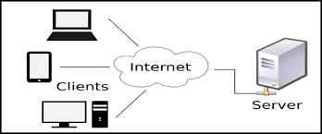

3) Design a simple HTTP client-server communication in any language.

Ans: _________

4). Research different types of internet connections (e.g., broadband, fiber, satellite) And list their pros and cons..

Ans:

* Fiber Optic Internet:

Pros: Extremely fast speeds (up to 10 Gbps), high reliability, and good security.

Cons: Limited availability, higher initial cost, and potential for damage.

* Satellite Internet:

Pros: Widely available, especially in remote areas, and can be a good option when other internet types are unavailable.

Cons: Slower speeds, high latency, and susceptibility to weather interference.

* Cable Internet:

Pros: Good speeds, reliable, and widely available.

Cons: May experience slowdowns during peak usage, shared bandwidth, and potential for signal degradation.

* DSL Internet:

Pros: Affordable and widely available.

Cons: Slower speeds, less reliable than fiber or cable, and limited availability in certain areas.

5) Simulate HTTP and FTP requests using command line tools (eg.curl)

Ans: _________

6). Identify and explain three common application security vulnerabilities suggest possible solution.

Ans.

1. SQL Injection

* Explanation:
* SQL injection occurs when an attacker crafts malicious code that is injected into a database query, tricking the application into executing unintended commands. This can lead to data breaches, unauthorized access, and even system compromise.
* Example:
* An attacker might inject code into a user input field to manipulate a SQL query and gain access to sensitive data or modify database records.
* Solutions:
* **Use parameterized queries:** This approach separates the SQL query from the user input, preventing the injection of malicious code.
* **Validate and sanitize user input:** Before processing user input, ensure it is sanitized and validated to remove potentially harmful characters or code.
* **Implement a web application firewall (WAF):** A WAF can help detect and block SQL injection attempts.

2. Cross-Site Scripting (XSS)

* Explanation:
* XSS vulnerabilities allow attackers to inject malicious scripts into a web page that other users will then view. These scripts can steal user data, redirect users to malicious sites, or manipulate the user's browser.
* Example:
* An attacker might inject a script into a website's comments section, and when another user views the comment, the script will execute in their browser, potentially stealing their login credentials or other sensitive information.
* Solutions:
* **Output encoding and escaping:** Encode and escape all user-provided data before displaying it on the web page to prevent scripts from being executed.
* **Use a Content Security Policy (CSP):** CSP allows you to define a whitelist of trusted scripts that can be executed on your website, preventing the execution of malicious scripts.
* **Implement a WAF**: A WAF can help detect and block XSS attacks.

3. Broken Authentication

* Explanation:
* Broken authentication vulnerabilities allow attackers to bypass login systems and gain unauthorized access to an application or system. This can happen due to weak passwords, improper session management, or flawed authentication mechanisms.
* Example:
* An attacker might guess a user's password, use a stolen session cookie, or exploit a vulnerability in the authentication process to gain access to a protected area of an application.
* Solutions:
* **Use strong passwords and multi-factor authentication (MFA):** Encourage users to use strong, unique passwords and implement MFA to add an extra layer of security.
* **Implement secure session management:** Store session information on the server-side and use secure cookies.
* **Regularly audit and patch authentication mechanisms:** Keep authentication mechanisms up-to-date and patch any vulnerability as soon as they are discovered.

7) Identify and classify 5 application use daily as either system software or application software.

Ans:

|  |  |  |
| --- | --- | --- |
| Web Application | Purpose | Category |
| Google Chrome (Web Browser) | Browsing the internet, accessing websites, using web apps | Application Software |
| Microsoft Word(Word processor) | Creating and editing documents | Application Software |
| Spotify(Music Streaming App) | Listening to music and podcasts | Application Software |
| Whatsup(Messaging app) | Sending texts, making voice/video calls | Application Software |
| You Tube(Video Streaming App) | Watching videos,tutorials,entartainment | Application Software |

8) Design a basic three-tier software architecture diagram for a web application.

Ans:

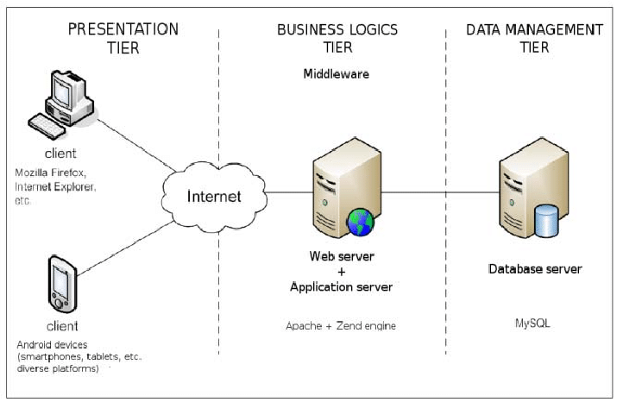

9) Create a case study on the functionality of the presentation, business logic, and data access layers of given software system.

Ans:

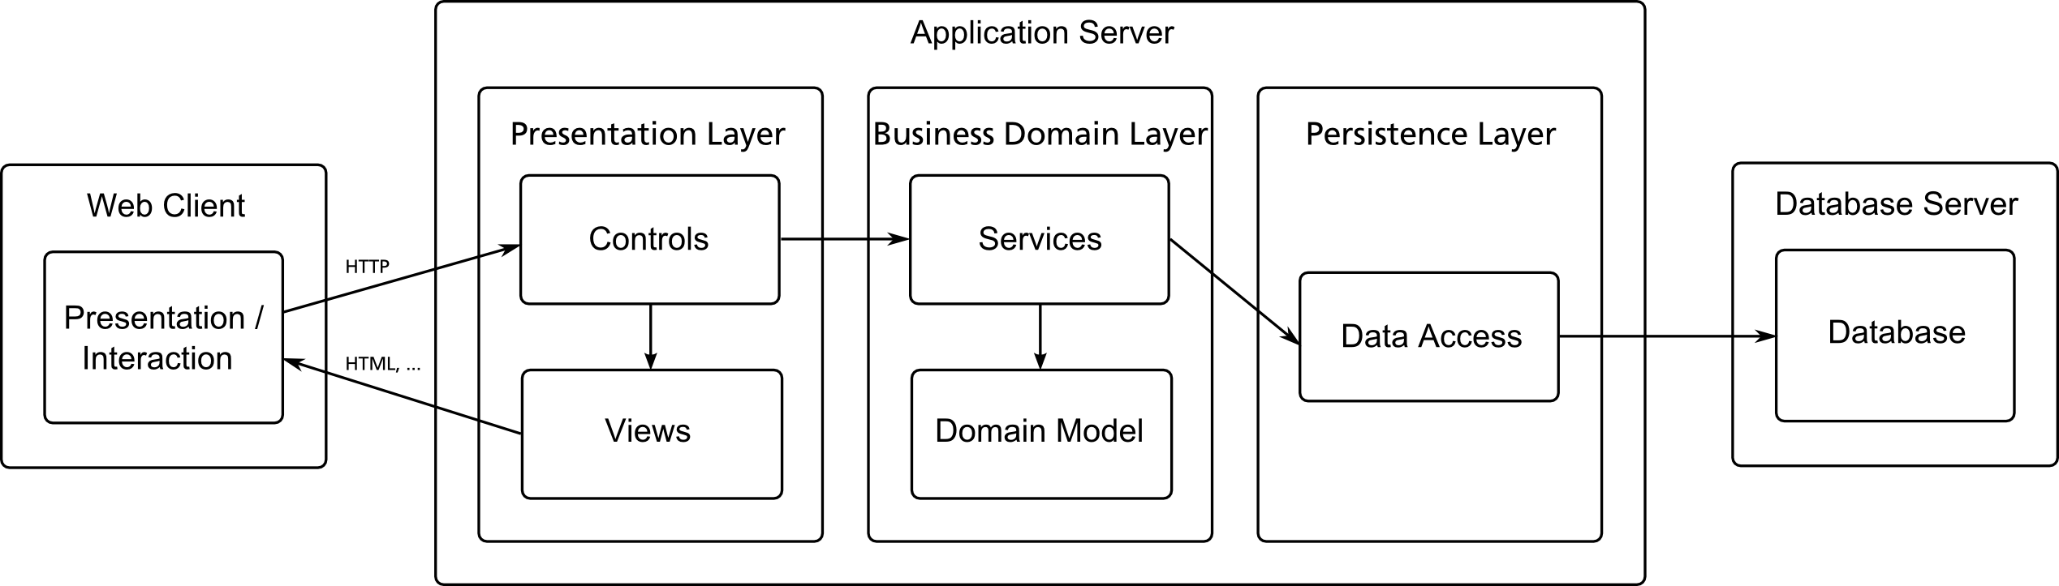

10) Explore different types of software environments (development, testing, production).set up a basic environment in a virtual machine.

Ans: Software environments can be broadly categorized into development.

* Development Environment:
* This is where developers create, modify, and test the software. It's a sandbox where they can experiment and build without affecting other systems.
* Testing Environment:
* This environment is used by quality assurance (QA) teams to ensure the software meets quality standards. It includes various testing phases like unit testing, integration testing, and user acceptance testing (UAT).
* Production Environment:
* This is the live environment where end-users access the software. It's the environment where the software is deployed and used by the public.

Setting up a Basic Environment in a Virtual Machine:

1. Install Virtualization Software:

Choose virtualization software like Virtual Box or VMware.

2. Create a Virtual Machine**:**

Use the software to create a new virtual machine and configure its resources (memory, storage).

3. Install an Operating System**:**

Install a desired operating system like Linux or Windows within the virtual machine.

4. Install Software Tools:

Install necessary software tools like IDEs, version control systems (Git), and databases for development, testing, and deployment.

5. Configure the Environment:

Configure the environment to match the specific requirements of the software project.

11) Write and upload your first source code file to a Github.

Ans:

Step 1: Create a new repository for your project

Step 2: Upload files to your project’s repository.

Step 3: Edit the README file for your project’s repository

12) Create a Github repository and document how to commit and push code changes.

Ans: _____________

13) Create a student account to Github and collaborate on a small project with a classmate.

Ans. _________

14) Create a list of software you use regularly and classify them into the following categories: System, Application, and Utility software

Ans:

System Software:

Operating System: Windows, macOS, Linux

Device Drivers: For printers, graphics cards, etc

BIOS/UEFI: Basic Input/Output System or Unified Extensible Firmware Interface

Application Software:

Office Productivity: Microsoft Word, Excel, PowerPoint, Google Docs, Sheets, Slides

Web Browsers: Chrome, Firefox, Safari, Edge

Communication: Zoom, Skype, Slack, Microsoft Teams

Multimedia: Spotify, Apple Music, VLC Media Player

Image Editing: Adobe Photoshop, GIMP

Project Management: Asana, Trello, Monday.com

Cloud Storage: Google Drive, Dropbox, One Drive

Utility Software:

Antivirus: Norton, McAfee, Avast, Windows Defender

Disk Cleanup: Disk Cleanup tool (Windows)

File Compression: 7-Zip, WinRAR

File Management: File Explorer, Finder, Terminal

Backup: Windows Backup, Time Machine, cloud backup services

System Optimizers: CCleaner

Types of Application Software: A Detailed guide - Fingent

A suite of Microsoft products such as MS Office, PowerPoint, MS Word, Excel, and Outlook. Internet browsers like Google Chrome,

15) Follow a Github tutorial to practice cloning, branching, and merging repositories.

Ans: __________

16) Write a report on the various types of application software and how they improve productivity.

Ans: Types of application software:

1. Productivity software
2. Collaboration and communication software
3. Graphic design software
4. Multimedia software
5. Web browser
6. Enterprise software
7. Other specialized software

* How to application software improve productivity:
* Automation
* Efficiency
* Organization
* Collaboration
* Access to information

17) Create a flowchart representing the Software Development Life Cycle (SDLC).

Ans:

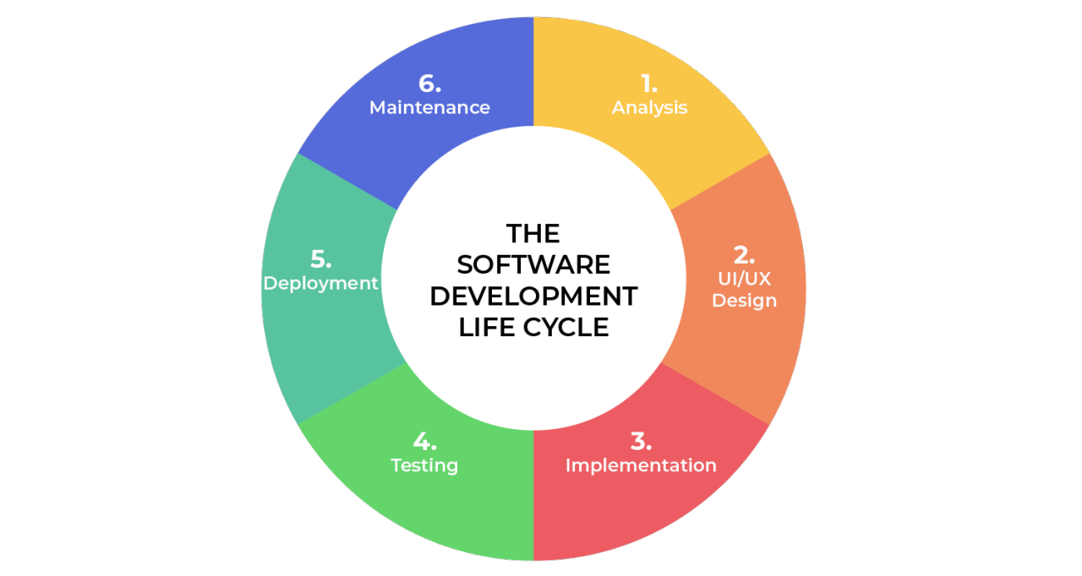

18) Write a requirement specification for a simple library management system.

Ans:

Team formation

Topic selection

Creating project Synopsys

Requirement gathering

Coding or implementation

Testing

Project presentation

Writing a research paper

19) Perform a functional analysis for an online shopping system.

Ans: Functional Requirements are what of your website. It is all about the functions and core operations of your e-source that enable a user to take action on the website. They can be implemented as a single website feature and form the basis of the whole software development process.

Functional Requirements:

* Third-party integration
* Mobile-friendliness
* Product attributes
* Order and checkout flow
* Social sharing